SECTION GG

FUEL PUMP CAMBOXES

CONTENTS

|  |  |
| --- | --- |
| Removal | Chapter  1 |
| Dismantling .. | 2 |
| Inspection | 3 |
| Assembly | 4 |
| Fitting.. | 5 |
| Special Tools .. | 6 |

CHAPTER 1

REMOVAL

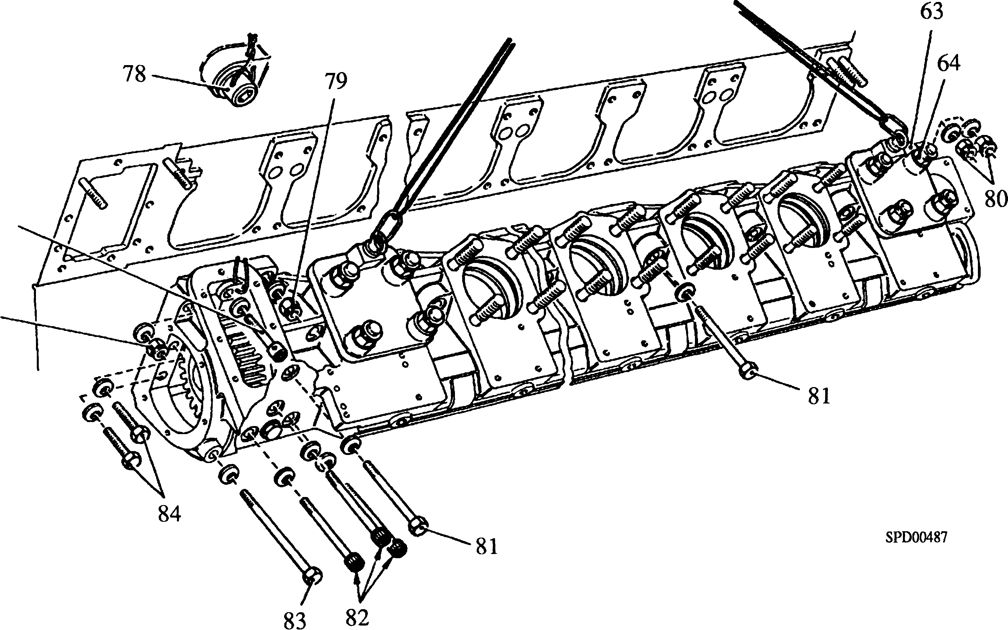

Key to Numbers.

|  |  |  |  |
| --- | --- | --- | --- |
| 63. | Lifting bracket | 81. | Setbolt |
| 64. | Philidas nut | 82. | Capscrew |
| 78. | Capscrew | 83. | Setbolt |
| 79. | Philidas nut | 84. | Setscrew |
| 80. | Philidas nut |  |  |

Fig GG.l Lifting fuel pump cambox.

Drain the engine and secondary cooling systems (Section KA).

Drain the fuel system (Section GB).

Remove the covers from the fuel injection pump control linkage (Section HC).

Remove the inspection cover or lubricating oil filler ('B' bank cambox) or fuel limiter ('A' bank cambox) (Section HB) to gain access to capscrew (78)(Fig GG.l).

Remove the fuel injection piping in way of cambox removal (Section GJ).

Release the fuel supply piping from the reservoir at the upper and lower fuel rails. Release the fuel supply piping at the fuel injection pumps. Release the clamps securing the lower fuel rails to the cambox and remove the rail complete with the supply connections.

Remove the air inlet manifold complete with the upper fuel rail (Section LC).

Remove the longitudinal fuel injection pump control linkage from the cambox (Section HC).

1. If removing 'B' bank cambox, release the fuel supply piping and remove the fuel feed pump and drive (Section GC).
2. Remove philidas nuts (38)(Fig GG.7), plain washers (37) and remove fuel injection pumps and shims. Keep each shim with its pump. Withdraw lubricating oil transfer ferrules (51) from the cambox and remove 'O' rings (39) from the cambox apertures.
3. Remove the lubricating oil supply banjo screws at each fuel injection pump position and remove the supply pipe.
4. Remove the lubricating oil supply pipe between the engine free-end cover and the fuel pump cambox.
5. Remove the oil drain connection between the oil drain cover (41) and the crankcase door (Section FH).
6. Remove the dipstick door complete with dipstick and guide tube (Section FH).
7. Remove the coolant piping between the coolant pump and the fuel pump camboxes.
8. If applicable, remove the coolant piping to the remote mounted pre-heating unit (Section K).
9. Fit lifting brackets (63)(Fig GG.l) at the free-end and drive-end fuel injection pump positions, and secure with philidas nuts (64). Attach a suitable wire sling to the oval links and apply tension.
10. Remove drive-end cover (28) or (30)(Fig GG.7) to gain access to the fastenings inside the cambox. Break the locking wire and remove capscrew (78)(Fig GG.l). Remove setscrews (84), philidas nuts (79) and (80), capscrews(82) and setbolt (83). Remove remaining setbolts (81) securing the cambox to the crankcase, draw the cambox away to free the locating keys and studs, and place on a suitable bench or trestle.

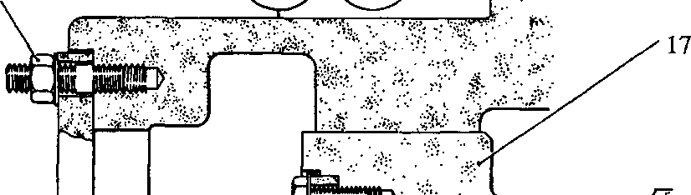image148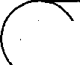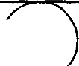SPD00488

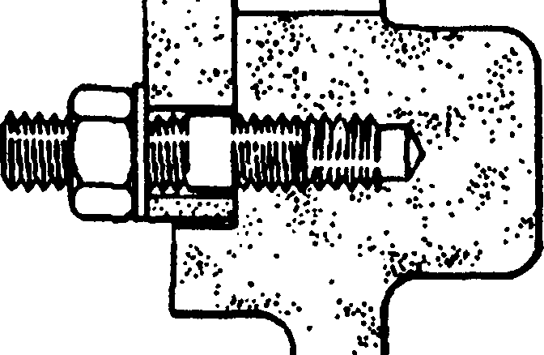

•J

$ ••••

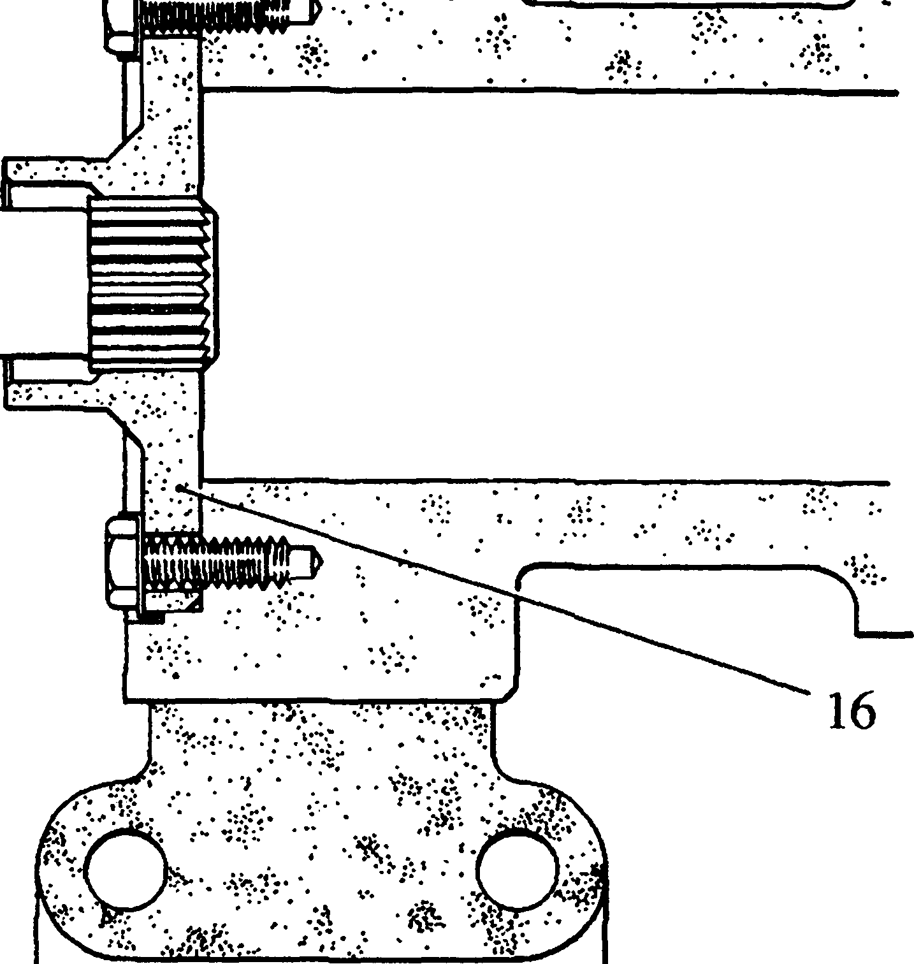

»T73r rwnr—

CHAPTER 2

**DISMANTLING**

66

O O

Key to Numbers.

1. Drive coupling
2. Fuel pump camshaft
3. Locking plate
4. Plain nut

Fig GG.2 Method of locking camshaft.

1. Remove philidas nuts (13)(Fig GG.7) and free-end cover (10). M8 tapped holes are provided for jacking purposes.
2. Withdraw the oil transfer shaft (57) or oil transfer shaft/bevel gear (46) from the drive coupling.
3. Remove setscrews (32), blank covers (34), and oil drain cover (41) from the underside of the cambox.
4. Fit locking plate (65)(Fig GG.2) engaging it with the splines in drive coupling (16) and the studs for the free-end cover. Secure in position with plain nuts (66).
5. Bend back tabwasher (26)(Fig GG.7), remove setscrew (27), and retaining plate (24).
6. Screw nut (68)(Fig GG.3) as far as possible onto the stem of adaptor (69). Place distance piece (67) and retaining plate (24) on the stem. Check that the cut-away in the retaining plate tongue faces towards the gear hub.
7. Screw the adaptor into the end of the camshaft and tighten firmly to form a hydraulic seal. Locate the retaining plate over the locating dowel and into the hub cut-away, slide the distance piece (67) into contact with the plate and tighten nut (68) to lock in position.
8. Screw cylinder (70) of hydraulic pump into the adaptor and tighten firmly to form a hydraulic seal.
9. Remove locking plate (65)(Fig GG.2), rotate the camshaft to bring cylinder (70) (Fig GG.3) to the vertical, and refit the locking plate.
10. Slacken nut (68) A MAXIMUM OF HALF A TURN.
11. Partially fill cylinder (70) with clean oil, insert plunger (71) and screw on sleeve (72) until a resistance is felt. Continued screwing on of the sleeve will cause the oil to be injected between gear hub (21) and camshaft (17), expanding the bore of the gear hub and allowing it to move down the camshaft taper. Continue to screw on sleeve (72) whilst slackening back nut (68) until the gear hub is free. This will be indicated by a loss of pressure at the pump. In some instances hydraulic pressure alone may be insufficient to start the gear hub, in which case the portion of the drive gear protruding from the cambox can be given a sharp tap with a plastic mallet to cause the gear hub to release its grip on the camshaft

CAUTION AS ALREADY STATED IN PARAGRAPH 2.10, NUT MUST NOT BE SLACKENED OFF MORE THAN A HALF TURN BEFORE APPLYING HYDRAULIC PRESSURE. THE INITIAL MOVEMENT OF THE GEAR HUB IS ABRUPT AND IF TOO MUCH MOVEMENT IS PERMITTED DAMAGE MAY RESULT.

Remove the hydraulic pump, adaptor, distance piece and retaining plate. Remove the locking plate from the free-end of the cambox.

2.12

2.13

2.14

2.15

2.16

2.17

Fit guide tube (74)(Fig GG.4) to the free-end of the cambox and secure with plain washers and philidas nuts (13)

Fit split collars (73) either side of the camshaft journal next to the drive-end and secure with capscrews (75). Check that the heads of the capscrews are below the surface of the collars and that the 'lead-in' of the collars point away from the journal.

Slide the camshaft towards the free-end of the cambox until the taper is free of gear hub (21)(Fig GG.7) and remove the hub complete with the drive gear. Slide the camshaft out of the cambox and place on a bench or suitable trestle.

Remove philidas nuts (25), tap the fitting bolts (19) through drive gear (22), and separate drive gear, gear hub and washer plate (20).

Bend back tabwashers (15), and remove drive coupling (16) and tappet adjustment indicator (55) if dismantling 'A' bank cambox.

CHAPTER 3

INSPECTION.

1. Measure and record all dimensions and compare with Schedule of Clearances and Wear Limits (Section CD).
2. Cambox. Thoroughly clean the cambox and remove all traces of old jointing material. Examine all mating and sealing faces for burrs and indentations that could impair sealing. Examine the coolant passages for scale formation, corrosion and erosion. Check that all oilways are clear. Check locating keys (2)(Fig GG.7) for security and fretting.
3. Oil transfer ferrules. Check the transfer ferrules (51) for serviceability. The ferrules incorporate a non-return valve to prevent a possible back-flow of fuel oil into the lubricating oil system, and if they are suspect in any way they should be renewed.
4. Camshaft. Examine the journals, cams and thrust shoulder (18) for scoring. Check that all oilways are clear. Examine the oil transfer shaft/bevel gear and the drive coupling for excessive wear or fretting of the splines.
5. Drive gear assembly. Examine the teeth of the drive gear and bevel gear, if fitted, for ridging, pitting or plucking. Carefully stone out any such marks using a fine oilstone.
6. Check all threaded components for serviceability.

CHAPTER 4

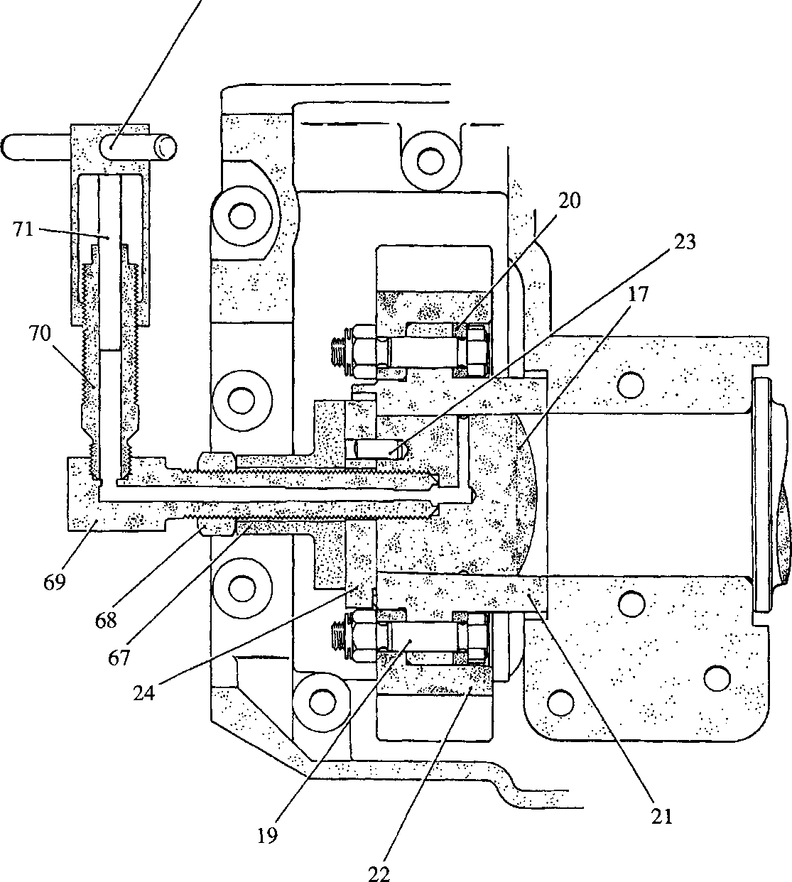ASSEMBLY

**SPD00489**

Key to Numbers.

|  |  |  |  |
| --- | --- | --- | --- |
| 17. | Camshaft | 67. | Distance piece |
| 19. | Fitting bolt | 68. | Nut |
| 20. | Washer plate | 69. | Adaptor |
| 21. | Gear hub | 70. | Cylinder |
| 22. | Drive gear | 71. | Plunger |
| 23. | Locating dowel | 72. | Sleeve |
| 24. | Retaining plate |  |  |

Fig GG.3 Removing and fitting drive gear.

NOTE All joints and 'O' rings must be fitted dry.

1. ’B’ Bank Camshaft. Fit drive coupling (16)(Fig GG.7) and secure with tabwashers

(15) and setscrews (14).

|  |  |  |  |
| --- | --- | --- | --- |
| Key | to Numbers. |  |  |
| 13. | Philidas nuts | 73. | Split collars |
| 17. | Camshaft | 74. | Guide tube |
| 21. | Gear hub | 75. | Capscrew |

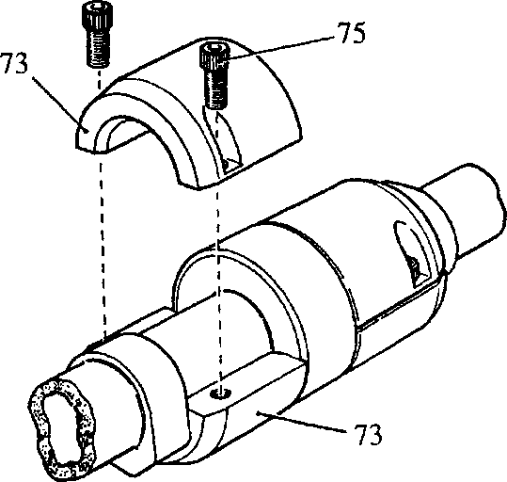Fig GG.4 Removal of camshaft from fuel pump cambox

73

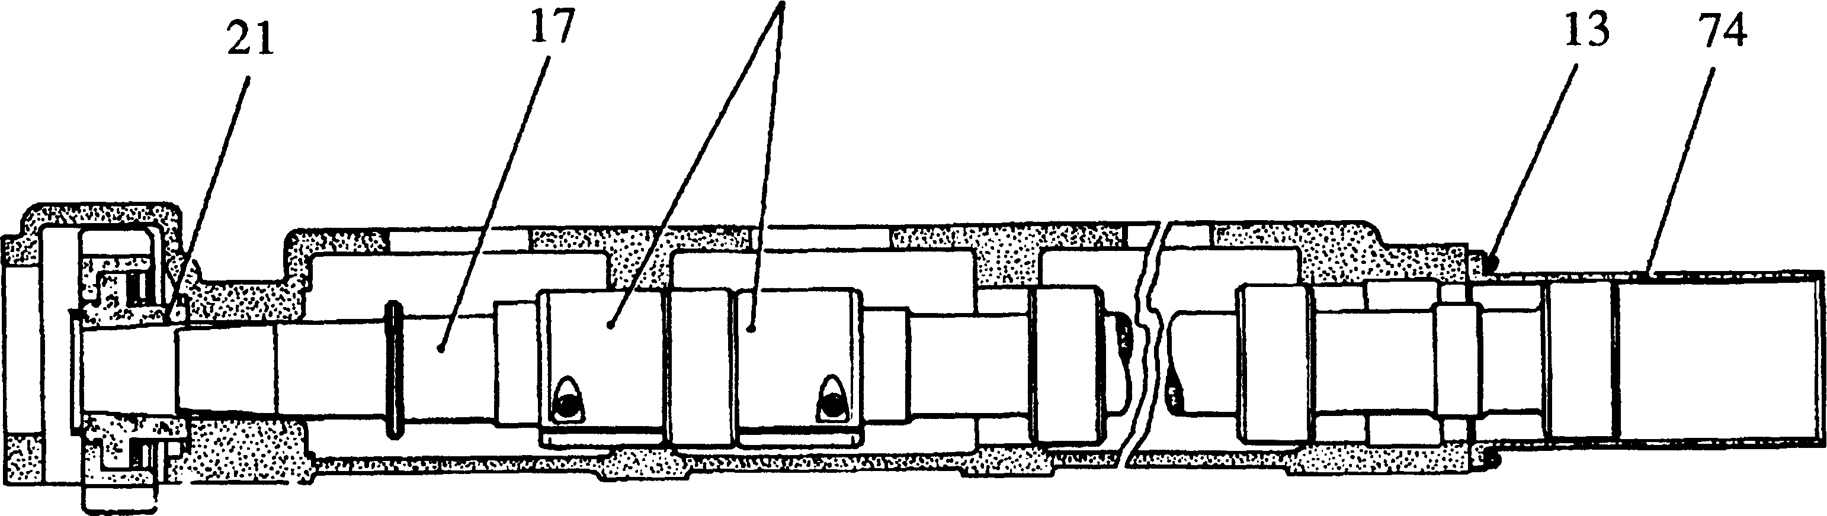

**SPD00490**

1. 'A' Bank Camshaft. Fit drive coupling (16) and tappet adjustment indicator (55). Ensure that 'O' marks (76)(Fig GG.5) on the end of the camshaft (17) and indicator (55) are correctly aligned. Secure with tabwashers (15) and setscrews (14).
2. Fit split collars (73)(Fig GG.4) to either side of the journal next to the drive-end and clamp together with capscrews (75). Check that the heads of the capscrews are below the surface of the collars and that the 'lead-in' on the collars point away from the journal.
3. Fit guide tube (74) to the free-end of the cambox and secure with plain washers and philidas nuts (13).
4. Assemble drive gear (22)(Fig GG.6), gear hub (21) and washer plate (20)(Fig GG.7) as follows:-
5. Place retaining plate (24)(Fig GG.6) in position in the hub ensuring that the relieved portion of the locating tongue is towards the hub.
6. Place the drive gear in position over the gear hub ensuring that the 'T' marks (77) on the gear and retaining plate are aligned.
7. Place washer plate (20)(Fig GG.7) in position at the rear of the hub. Pass fitting bolts (19) through the plate, hub and gear, fit and 'nip-up' philidas nuts (25). Remove the retaining plate.

17

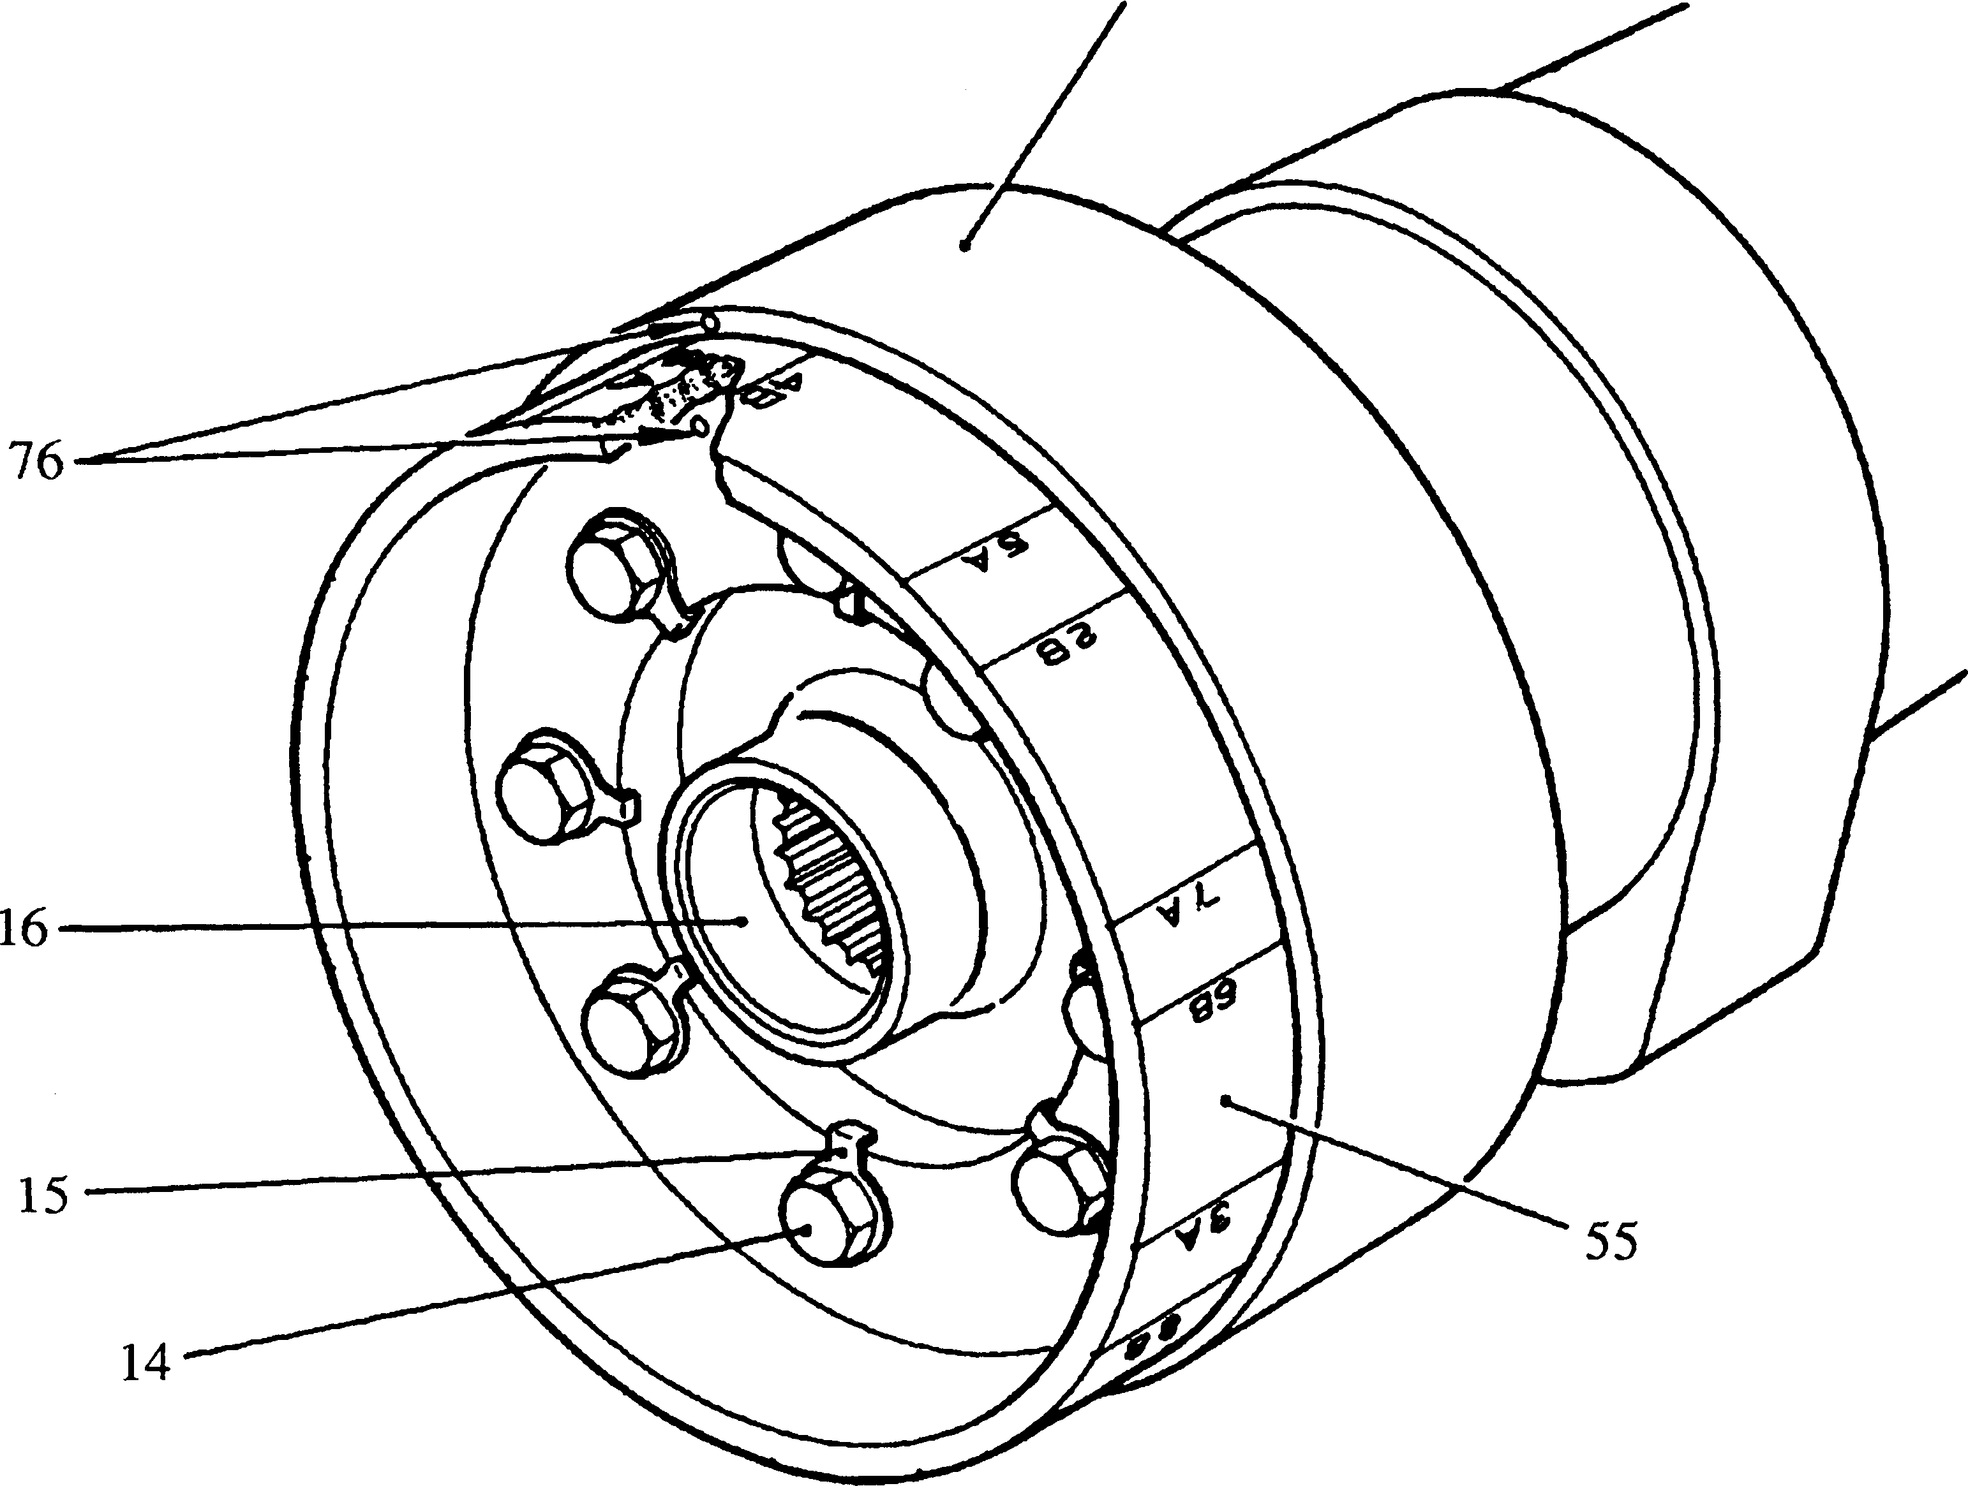

|  |  |  |
| --- | --- | --- |
| 4Key to Numbers. |  |  |
| 14. Setscrew | 17. | Camshaft |
| 15. Tabwasher | 55. | Tappet adjustment indicator |
| 16. Drive coupling | 76. | 'O' marks |

Fig GG.5 Alignment of tappet adjustment indicator to camshaft.

1. Place the drive gear in its compartment in the cambox and insert the camshaft through the guide tube until the thrust shoulder butts against the thrust face of the cambox. Locate the gear hub on the camshaft during the last stage of insertion. Check that the camshaft rotates freely by hand.
2. Remove the guide tube and split collars.
3. Fit locking plate (65)(Fig GG.2) to the free-end of the cambox, engaging the splined shaft with drive coupling (16) and locating the plate on the studs for the free-end cover. Secure in position with plain washers and nuts (66).
4. Screw nut (68)(Fig GG.3) as far as possible onto the stem of adaptor (69). Place distance piece (67) and retaining plate (24) on the stem, making sure that the relieved portion of the tongue faces away from the distance piece.
5. Check that locating dowel (23) is in position. Screw the adaptor into the camshaft and tighten firmly to form a hydraulic seal. During this procedure engage retaining plate (24) with locating dowel (23) and the cutaway in the gear hub, rotating the hub relative to the camshaft as necessary to obtain alignment. Slide distance piece (67) into contact with the retaining plate, and tighten nut (68) sufficiently to hold the gear hub firmly on the camshaft taper.
6. Screw cylinder (70) of hydraulic pump into the adaptor and tighten firmly to form a hydraulic seal. If necessary, release the locking plate at the free-end of the camshaft, rotate the camshaft to bring the cylinder vertical and refit the locking plate.

LIMITED RIGHTS LEGEND

1 ft USE, DUPLICATION OR DISCLOSURE OF THIS INFORMATION WHICH IS THE PROPERTY

1 U OF GEC ALSTHOM DIESELS LIMITED BY THE U.S. GOVERNMENT OR BOLLINGER IS

SUBJECT TO THE RESTRICTIONS SET FORTH IN DOD FAR SUPP 252.227-7013 (a) 15.

Key to Numbers.

1. 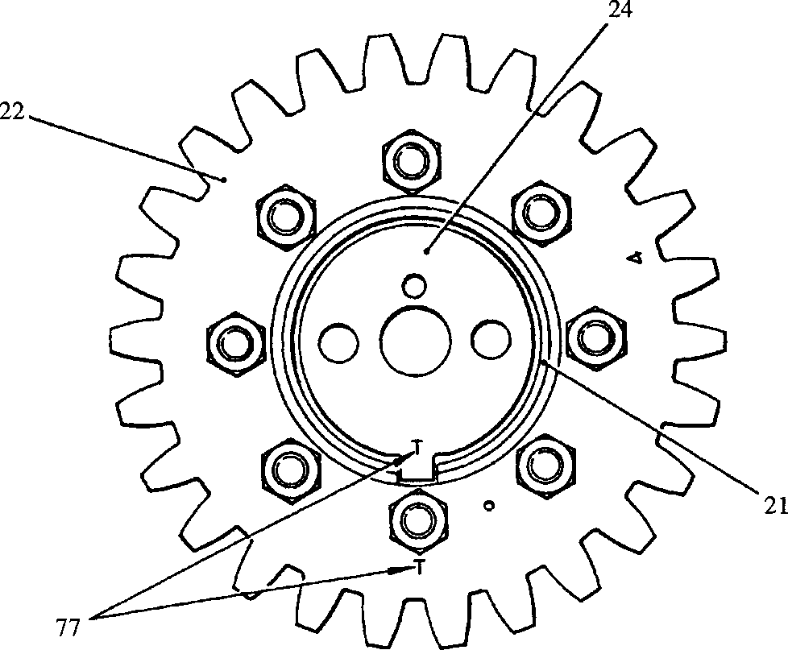Gear hub

24 Retaining plate 77. T marks

**SPD00492**

1. Drive gear

Fig GG.6 Alignment, fuel pump drive gear to gear hub.

1. Partially fill cylinder (70) with clean oil. Insert plunger (71) and screw on sleeve (72) until resistance is felt. Continued screwing on of the sleeve will cause oil to be injected between gear hub (21) and camshaft (17), expanding the bore of the gear hub allowing it to move up the taper. Whilst applying hydraulic pressure, screw up nut (68) to press the gear hub on to the camshaft. DO NOT apply undue force on the nut, but rely rather on an increase in hydraulic pressure. When the hub has been pressed on the correct distance the retaining plate will butt against the end of the camshaft and the nut will become solid.
2. Release the hydraulic pressure and check the end float against the figures quoted in Schedule of Clearances and Wear Limits (Section CD).
3. Remove the cylinder, adaptor, and distance piece. Refit retaining plate (24), new tabwasher (26)(Fig GG.7) and setscrew (27). Tighten to the torque loading quoted in Section CE. Bend up the tabwasher to lock.
4. Remove locking plate (65)(Fig GG.2).
5. Fit a new 'O' ring (56)(Fig GG.7) to oil transfer shaft (57) ('A' bank only - no 'O' ring is fitted to bevel gear (46) if assembling 'B' bank cambox), lubricate the splines, and engage the shaft with drive coupling (16).
6. Fit new 'O' rings (62), (53) and (9) to free-end cover (10) and fit the cover to the cambox ensuring that the oil supply drilling inlet face (11) is in the same plane as the cambox mounting faces. Secure with plain washers and philidas nuts (13).

NOTE Free end cover (10) is a common cover for use with both 'A' and 'B* bank camboxes. Two oil supply drillings are provided in the cover for fuel feed pump drive lubrication, one drilling will coincide with the drilling in the cambox, while the other is presented to a blank face. It is important that 'O' rings (62) and (53) are both fitted, otherwise oil leaks will result.

1. If the fuel feed pump is NOT required, fit a new 'O’ ring (42) to blanking plug (43), insert the plug in the cambox and secure with plain washers and setscrews (44).
2. Using new joints fit blank covers (34) and oil drain cover (41) and secure with plain washers (33) and setscrews (32). The oil drain cover is fitted to the free-end aperture.
3. Fit locating keys (2) to the free-end and drive-end of the cambox, and secure with capscrews (1).

CHAPTER 5

FITTING

NOTE All joints and 'O' rings must be fitted dry.

1. Referring to Section CC, position the crankshaft and fuel pump camshaft correctly for timing purposes. It may be found advantageous to apply yellow paint to the gear teeth marked with '4'.
2. Fit lifting brackets (63)(Fig GG.l) at the free-end and drive-end fuel injection pump positions and secure with philidas nuts (64). Attach a suitable wire sling to the oval links and lift cambox.

NOTE The individual joints fitted between the cambox and crankcase must

all be of equal thickness to prevent cambox distortion. For this reason the joints are cut from one sheet and packed in sets which should be opened ONLY at the time of assembly and then fitted to one bank of the engine only as a complete set.

1. Place joints (3)(Fig GG.7), (5), (6) and (8) in position on the cambox mating faces.
2. Coat new 'O' rings with petroleum jelly and locate them in the crankcase mating faces corresponding with the coolant transfer ports (7).
3. Checking for the timing marks '4' on the camshaft drive gear and fuel pump idler gear, engage the cambox with the studs and slide into position. Ensure that locating keys (2) are engaged correctly with their keyways in the crankcase. Secure in position with sufficient domed washers and setbolts (81)(Fig GG.l) to make the cambox safe. Re-check the timing marks.
4. Fit remaining setbolts (81), capscrews (82), setbolt (83), setscrews (84), philidas nuts (79) and (80), and capscrew (78). Domed washers are fitted to all these fastenings. Tighten all fastenings to the torque loading quoted in Section CE and wire lock capscrew (78).
5. Check the backlash between the drive gear (22)(Fig GG.7) and the fuel pump idler is in accordance with Section CD Schedule of Clearances and Wear Limits.
6. Remove the lifting sling and brackets.
7. Check and if necessary adjust the fuel injection pump timing using dummy pump and timing injector (Section CC).
8. Using a new joint (31), fit drive-end cover (28) or (30). Secure with plain washers and setscrews (29).
9. Fit the coolant piping between the cambox and the coolant pump. If applicable, connect the coolant piping between the cambox and the remote mounted pre-heating unit.
10. Using new 'O' rings, fit the lubricating oil supply pipe between the engine free-end cover and the cambox free-end cover (10). Secure with plain washers and setscrews.
11. Fit the oil drain connection between oil drain cover (41) and the crankcase door (Section FH).
12. Place the lubricating oil supply pipe in position and secure to the cambox with banjo screws and copper washers.
13. Fit the air inlet manifolds (Section LC).
14. Fit the fuel injection pumps (Section GF).
15. Fit the longitudinal fuel injection pump control linkage, complete with the drain rail for the sheathed fuel injection piping.
16. Fit the upper fuel gallery to the air inlet manifold and the lower fuel gallery to the fuel pump cambox. Connect the fuel supply and return piping between the galleries, pumps and fuel reservoir.
17. Fit the fuel injection piping (Section GJ).
18. Fit the fuel limiter ('A* bank cambox only)(Section HB).
19. Fit the fuel feed pump (Section GC) and connect the fuel supply piping.
20. Using setting pins, set the fuel injection pump linkage (Section HC).
21. Set the fuel limiter (Section HB).
22. Fit the dipstick guide tube complete with crankcase door (Section FH).
23. Fit the fuel injection pump covers.
24. Prime and vent the fuel and cooling systems (Section DA).

CHAPTER 6

SPECIAL TOOLS

The following special tools are sufficient for carrying out all general maintenance, dismantling, overhaul and assembly operations on the fuel pump camboxes as detailed in this section.

NOTE These tools are only shown in the Illustrated Parts List if they have been ordered as part of the contract.

|  |  |  |
| --- | --- | --- |
| DESCRIPTION | PART NO | USE |
| Torque wrench 10 to 50 lbf ft  V2 in square drive | OD26977 | )  )  ) To tighten fastenings to a pre- |
| Torque wrench 50 to 250 lbf ft V2 in square drive | OD28465 | ) determined loading ) |
| Lifting brackets | Y3J70877A | To lift fuel pump cambox during removal and fitting |
| Locking plate | Y3J70786A | To prevent camshaft rotation during drive hub removal and assembly operations |
| Adaptor for pump | Y3J70875B | To provide connection between hydraulic pump and fuel pump camshaft |
| Distance piece | Y3J70785 | To provide reinforcement for retaining plate when fitting hub to camshaft |
| Hydraulic pump | OD9342 | To remove and fit drive hub to camshaft |
| Guide tube | Y3J70796 | To provide guide for free-end of camshaft during removal and fitting |
| Split collars | Y3J70797 | To provide guide for drive-end of camshaft during removal and fitting |

Key to numbers.

|  |  |  |  |
| --- | --- | --- | --- |
| 1. | Capscrew | 32. | Setscrew |
| 2. | Locating key | 33. | Plain washer |
| 3. | Cambox joint, drive-end | 34. | Blank cover |
| 4. | 'B' bank cambox | 35. | Joint |
| 5. | Joint, coolant transfer | 36. | Stud for injection pump |
| 6. | Joint, plain | 37. | Plain washer |
| 7. | Coolant transfer ports | 38. | 'Philidas' nut |
| 8. | Joint, free-end | 39. | 'O' rings |
| 9. | 'O' ring | 40. | ‘B’ bank cambox |
| 10. | Free-end cover | 41. | Oil drain cover |
| 11. | Oil supply drilling | 42. | 'O' ring |
| 12. | Stud | 43. | Blanking plug |
| 13. | 'Philidas' nut | 44. | Setscrew |
| 14. | Setscrew | 45. | 'O' ring |
| 15. | Tabwasher | 46. | Oil transfer shaft/bevel gear |
| 16. | Drive coupling | 47. | Retaining washer |
| 17. | Camshaft | 48. | Spring |
| 18. | Thrust shoulder | 49. | 'O' ring, seal to injection pump |
| 19. | Fitting bolt | 50. | Non-return valve ball |
| 20. | Washer plate | 51. | Ferrule body |
| 21. | Gear hub | 52. | 'O' ring, seal to cambox |
| 22. | Drive gear | 53. | 'O’ ring |
| 23. | Locating dowel | 54. | Setscrew |
| 24. | Retaining plate | 55. | Tappet adjustment indicator |
| 25. | 'Philidas' nut | 56. | 'O' ring |
| 26. | Tabwasher | 57. | Oil transfer shaft |
| 27. | Setscrew | 58. | Fuel feed pump drive |
| 28. | Drive end cover | 59. | 'Philidas' nut |
| 29. | Setscrew | 60. | 'O' ring |
| 30. | * Bracket for governor booster | 61. | Shim |
| 31. | Joint | 62. | 'O' ring |

* Optional item, replaced by Item (28) if governor booster is not fitted.

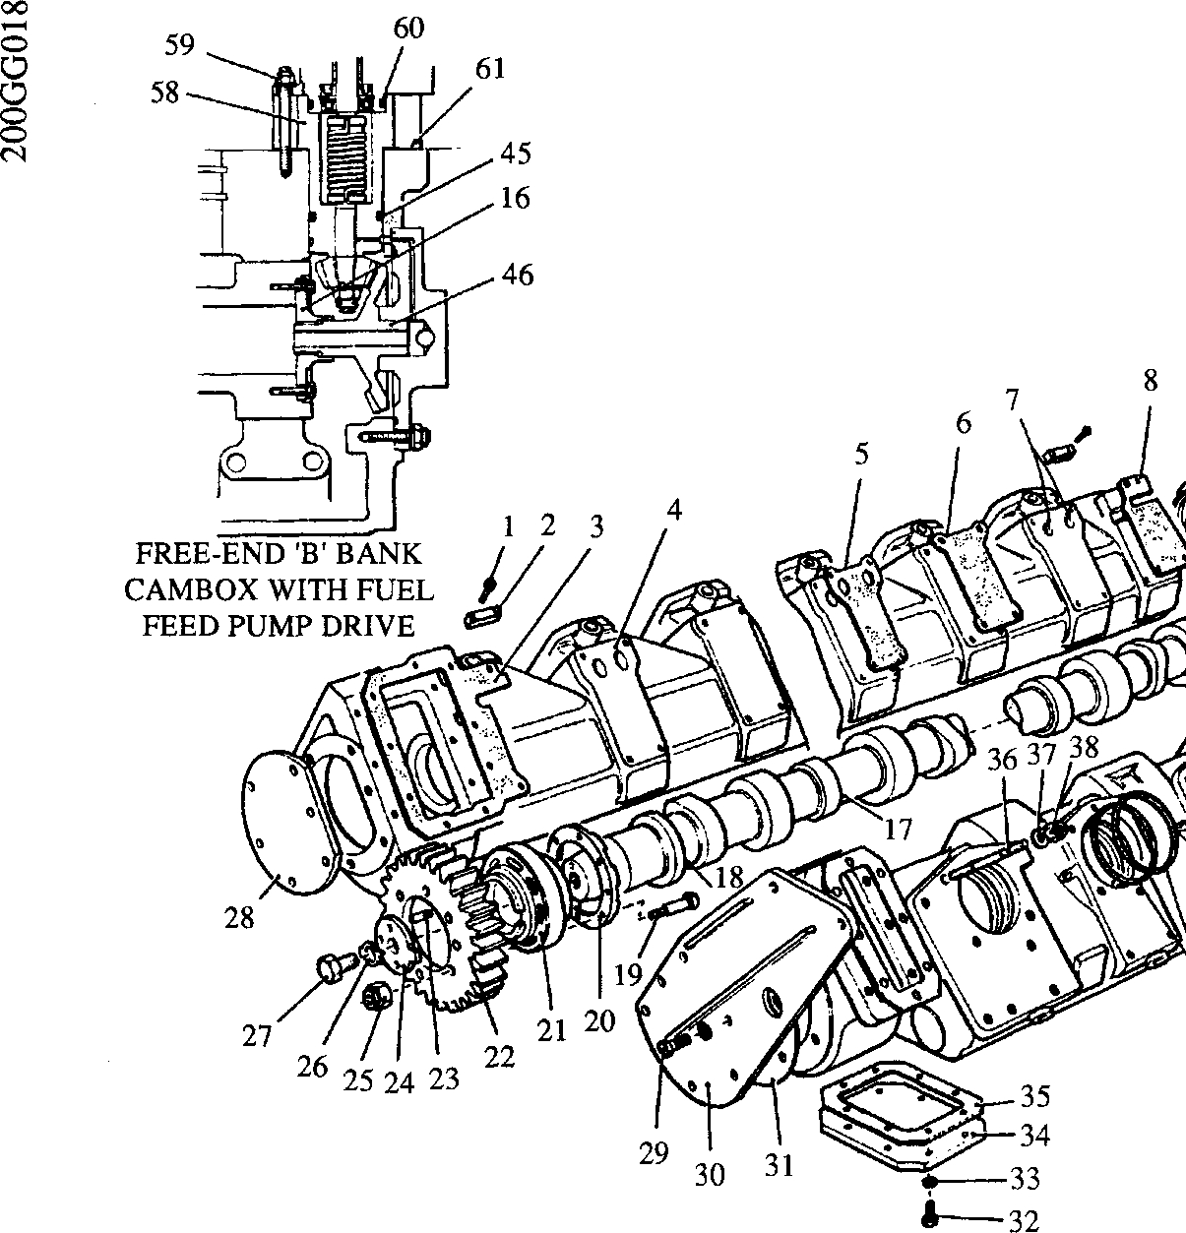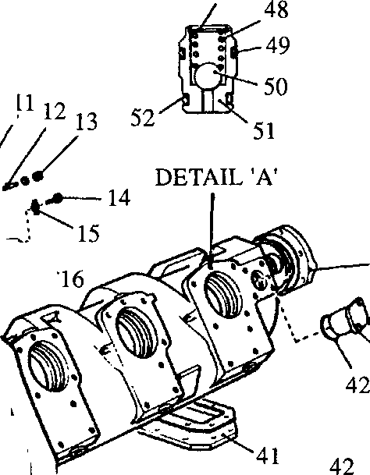Vi

47

43

62

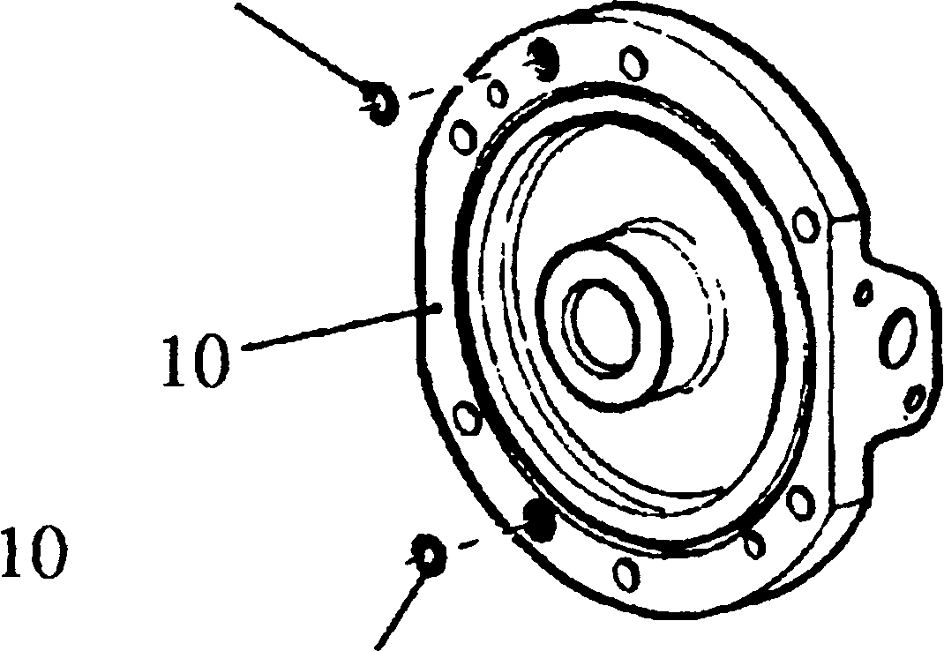

44

53

**DETAIL 'B'**

43

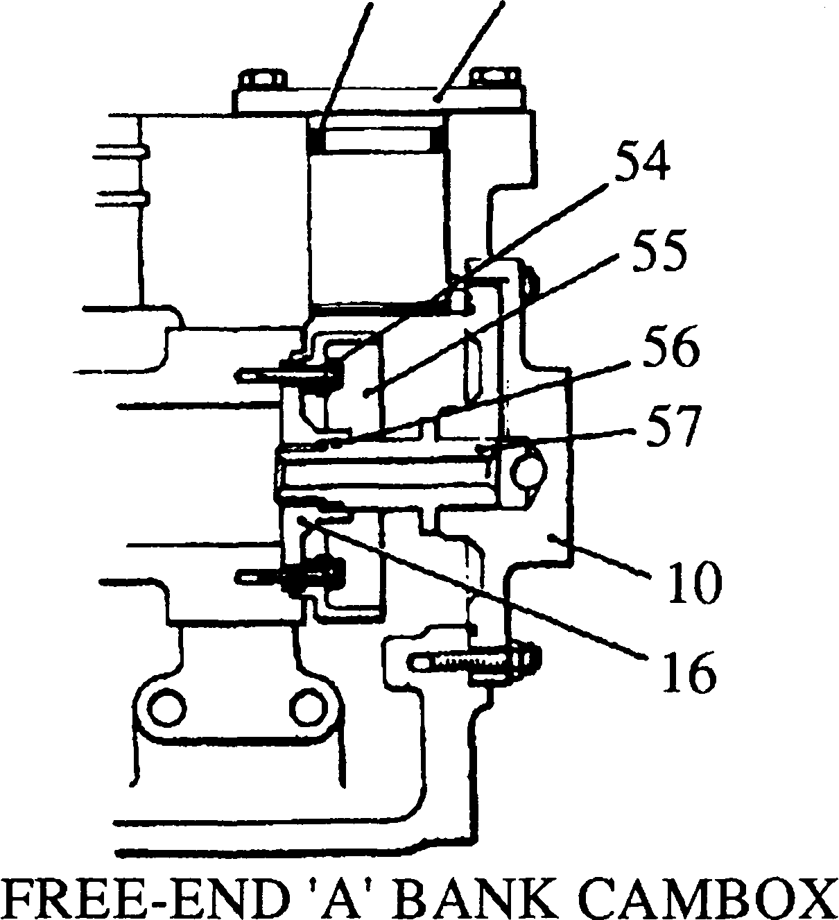

WITH TAPPET ADJUSTMENT INDICATOR

**SPD00493**

0>

X

O

■O es 3

a

*3

3

OX)

E